Pragati Education Study Notes of Periodic Table
PERIODIC CLASSIFICATION OF ELEMENTS
Important terms & condition:
Classification of elements: the arrangement of elements in such a manner that elements with similar
properties are grouped together while elements with dissimilar properties are separated.
EARLY ATTEMPTS OF CLASSIFICATION OF ELEMENTS
1. Lavoisier’s classification of elements: In 1789, Lavoisier first attempted to classify the elements into two divisions namely Metals and Non-metals. However this classification was not satisfactory as there were many exceptions in each category.
2. Dobereiner’s classification of elements: In 1817, Johann Wolfgang Dobereiner grouped three elements into what he termed triads.
In each case, the middle element has an atomic mass almost equal to the average atomic masses of the other two elements in the triad.
For example, elements like lithium, sodium and potassium have atomic masses 7, 23 and 39
respectively. They are grouped together into a triad as,
Li (7) Na (23) K (39)
Here the atomic mass of sodium is the average of atomic masses of lithium and potassium.
Limitation of Dobereiner‟s law
Only three triads were identified from the element known at that time. Hence, this classification was
not useful.
Newland‟s law of octaves:
In 1863, John Newland suggested another classification of elements . He arranged the elements in
the order of increasing atomic masses starting with hydrogen (least atomic mass) and ended with
thorium having atomic mass 56. According to him, the properties of every eighth element are similar
to the first element. It was compared to music notations Sa, Re, Ga, Ma, Pa, Da, Ni, Sa, and thus the
name Newland‘s law of octaves (note of music). He then arranged the 49 elements known at that
time into seven groups of seven each. Newland referred to his arrangement as the Law of octaves.
The Law of octaves: If elements be arranged in ascending order of their atomic masses then every
eighth element was a kind of repetition of the first one either succeeding or preceding it like eighth note in octave of music.
Periodicity : Periodicity is the recurrence of similar physical and chemical properties of elements when arranged in a particular order.
For example, Sodium is similar to Lithium. Similarly Magnesium is similar to Beryllium.
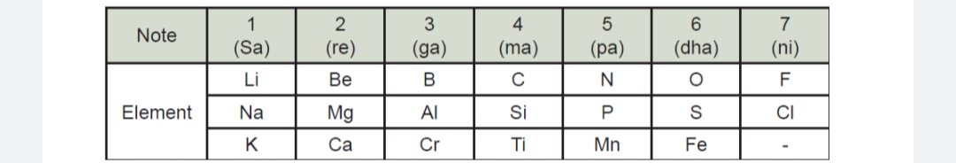
Limitations:
1. It was applicable only for lighter elements having atomic mass up to 40 amu, i.e.upto calcium.
2. He believed that only 56 elements existed in nature but later on more elements were discovered
whose properties did not fit into Newland’s law of octaves.
3. Some elements having different properties were grouped together like cobalt and nickel have been
placed with halogens. Due to above limitations, Newlands law of octaves was rejected.
Lothar Meyer‟s classification of elements:
In 1864, Lothar Meyer plotted atomic weight against atomic volume of various elements. He found
that elements with similar properties and valency fell under one another. However, this also could not
give the better understanding.
Mendeleev‟s periodic table:
Mendeleev (1834-1907), a Russian chemist arranged the elements in order of increasing atomic
masses, similarity in physical and chemical properties of elements. Properties of hydrides and oxides
of different elements were studied and elements with similar properties were grouped together
He classified the elements in table Consisted of vertical columns called groups and horizontal rows
called periods. There were 7 groups in table and group is subdivided into subgroups A and B except
group 7 which has three sets of elements in 4th, 5th and 6th period. (“R” is used to represent any
of the elements in a group) Limitations:
1. It was applicable only for lighter elements having atomic mass up to 40 amu, i.e.upto calcium.
2. He believed that only 56 elements existed in nature but later on more elements were discovered
whose properties did not fit into Newland’s law of octaves.
3. Some elements having different properties were grouped together like cobalt and nickel have been
placed with halogens. Due to above limitations, Newlands law of octaves was rejected.
Lothar Meyer‟s classification of elements:
In 1864, Lothar Meyer plotted atomic weight against atomic volume of various elements. He found
that elements with similar properties and valency fell under one another. However, this also could not
give the better understanding.
Mendeleev‟s periodic table:
Mendeleev (1834-1907), a Russian chemist arranged the elements in order of increasing atomic
masses, similarity in physical and chemical properties of elements. Properties of hydrides and oxides
of different elements were studied and elements with similar properties were grouped together
He classified the elements in table Consisted of vertical columns called groups and horizontal rows
called periods. There were 7 groups in table and group is subdivided into subgroups A and B except
group 7 which has three sets of elements in 4th, 5th and 6th period. (“R” is used to represent any
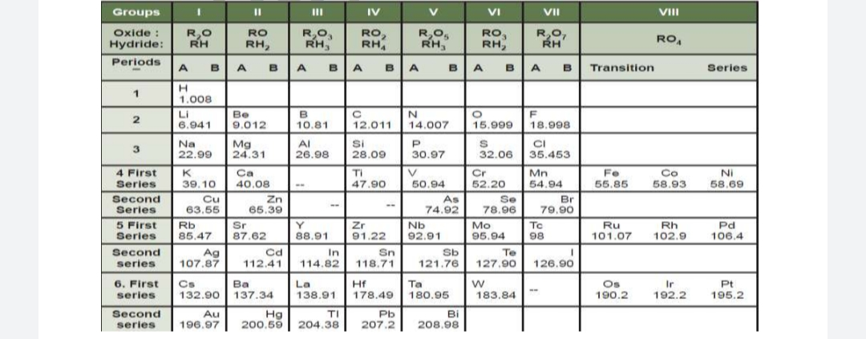
of the elements in a group) Mendeleev„s periodic table is mainly based on two facts-
(i)Atomic mass
(ii)Similarity of chemical properties
Mendeleev‟s periodic law : “The physical and chemical properties of elements are the periodic
functions of their atomic masses”.
Characteristics of Mendeleev‟s Periodic table:
1. Mendeleev felt that similar properties occurred after periods (horizontal rows) of varying length.
2. Mendeleev made an eight-column table of elements.
3. He had to leave some blank spaces in order to group all the elements with similar properties in
the same column.
4. Mendeleev suggested that there must be other elements that had not been discovered.
5. He predicted the properties and atomic masses of several elements that were known at that time.
Later on, when these elements were discovered their properties remarkably agreed with the predicted
one.
For example, He left a gap below silicon in group IV A, and called the yet undiscovered
element as „Eka silicon‟. Discovery of „Germanium‟ during his life time proved him correct.
6. Similarly Scandium for ‘eka-boron’ and Gallium for ‘eka-aluminium’ vacancies were later
discovered during his life time.
7. Eight out of ten vacant spaces left by Mendeleev were filled by the discovery of new elements.
8. Incorrect atomic masses of some arranged elements were corrected. For example, atomic mass
of Beryllium as corrected from 13 to 9.
Limitations of Mendeleev, periodic table:
1. Few elements having a higher atomic mass were placed before elements having a lower atomic
mass. Example: Argon (39.9) was placed before Potassium (39.1) Cobalt (58.9) was placed before
Nickel (58.6) Tellurium (127.9) was placed before Iodine (126.9)
2. No separate position has been given to isotopes of an element.
3. Position of hydrogen in the periodic table was not certain about keeping it with either in group IA or
in group VII A.
4. Chemically dissimilar elements were placed in the same group.
The difficulty in the Mendeleev’s periodic table is overcome by introduction of Modern periodic table.
It is also known as Long form of periodic table. In this table, properties of elements are dependent on
their electronic configurations (distributions). Hence, modern periodic law is defined as the properties
of elements are the periodic function of their atomic numbers.
Modern periodic table:
In 1913 Moseley found that frequency of X-ray emitted by different elements is directly proportional to
atomic number. These studies show that properties of elements depend upon atomic number but not
atomic mass.
So atomic number is the basis of classification of element. Moseley gave modern periodic law which
stated as
“The physical and chemical properties of the elements are periodic function of their atomic
number”
In this table, elements have been arranged in order of increasing atomic number. This table also
consists of vertical rows called groups and horizontal rows called periods which are
discussed as:
(i) There are 18 groups designated as 1 to 18.
(ii)All the elements in a group have same no. of electrons in outermost shell.
(iii)The elements of each group have similar chemical properties due to same valence electrons .
(iv)There are in all seven periods.
(v)First three periods with 2,8,8 element called short periods. The next three periods with 18,18,32
element called long period while seventh period is an incomplete period. (vi)The number of elements
in these periods are based on filling of electron into various shell on the formula 2n2
(n-number of
shell)
For Ex:-K-shell (n=1)-(2.1)2=2 so first period has two elements
L-shell (n=2)-(2.2)2=8. So 2nd period has eight elements.
M-shell (n=3)-(2.3)2=18, but the outer most shell can have only 8-electron so third period also has
eight elements.
Advantages of long form of periodic table:-
1. The position of the elements are linked with their electronic configuration.
2. Position of isotopes of an element is justified since they have same atomic number.
3. Similar properties of element in a group is also justified due to same valence electrons.
4. Each group is an independent group and idea of sub-group discarded.
Groups:
Elements in group 1 are called alkali metals.
Elements in group 2 are called alkaline earth metals.
Elements in group 17 are called halogens.
Elements in group 18 elements are called inert gases or noble gases.
Significance of group in the periodic table is that an element in a group has same no. of valence
electrons, valence and thus identical chemical properties.
Periods : Modern periodic table:
In 1913 Moseley found that frequency of X-ray emitted by different elements is directly proportional to
atomic number. These studies show that properties of elements depend upon atomic number but not
atomic mass.
So atomic number is the basis of classification of element. Moseley gave modern periodic law which
stated as
“The physical and chemical properties of the elements are periodic function of their atomic
number”
In this table, elements have been arranged in order of increasing atomic number. This table also
consists of vertical rows called groups and horizontal rows called periods which are
discussed as:
(i) There are 18 groups designated as 1 to 18.
(ii)All the elements in a group have same no. of electrons in outermost shell.
(iii)The elements of each group have similar chemical properties due to same valence electrons .
(iv)There are in all seven periods.
(v)First three periods with 2,8,8 element called short periods. The next three periods with 18,18,32
element called long period while seventh period is an incomplete period. (vi)The number of elements
in these periods are based on filling of electron into various shell on the formula 2n2
(n-number of
shell)
For Ex:-K-shell (n=1)-(2.1)2=2 so first period has two elements
L-shell (n=2)-(2.2)2=8. So 2nd period has eight elements.
M-shell (n=3)-(2.3)2=18, but the outer most shell can have only 8-electron so third period also has
eight elements.
Advantages of long form of periodic table:-
1. The position of the elements are linked with their electronic configuration.
2. Position of isotopes of an element is justified since they have same atomic number.
3. Similar properties of element in a group is also justified due to same valence electrons.
4. Each group is an independent group and idea of sub-group discarded.
Groups:
Elements in group 1 are called alkali metals.
Elements in group 2 are called alkaline earth metals.
Elements in group 17 are called halogens.
Elements in group 18 elements are called inert gases or noble gases.
Significance of group in the periodic table is that an element in a group has same no. of valence
electrons, valence and thus identical chemical properties.
Periods : Metallic and Non-metallic Properties
The metallic character of an element is expressed in terms of its electron releasing tendency while
non-metallic character in term of electron accepting tendency.
In group: Metallic character of the element increases down the group due to increasing atomic size or
because outermost electrons are farther away from the nucleus .So they can be easily lost.
In periods:- Metallic character of the element decreases along a period due to decrease in atomic
size along a period or outermost electrons are closer to nucleus. So they can not be easily lost.
NOTE:- Non-metallic elements follow the same reverse trend. In modern periodic table a zig - zag
line separates metals from Non-metals. The border line elements, B, Si, Ge, As, Sb, Te and Po are
called metalloids or semi-metal.

